Chapter 3: Displaying and Summarizing Quantitative Data

Part I: Histogram and Stem-and-Leaf plot

**Earthquakes Example:**

Source: NOAA (National Oceanic and Atmospheric Administration.)

1. **Histogram:**
2. Open the data file (Earthquakes.csv). In this file, there are four variables which are year, month, day, and magnitude.
3. Select the range of the magnitude variable.

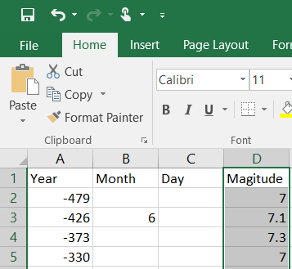

1. Select **Insert** tab $⟹$**Insert Statistic Cart $⟹$**  **Histogram**.

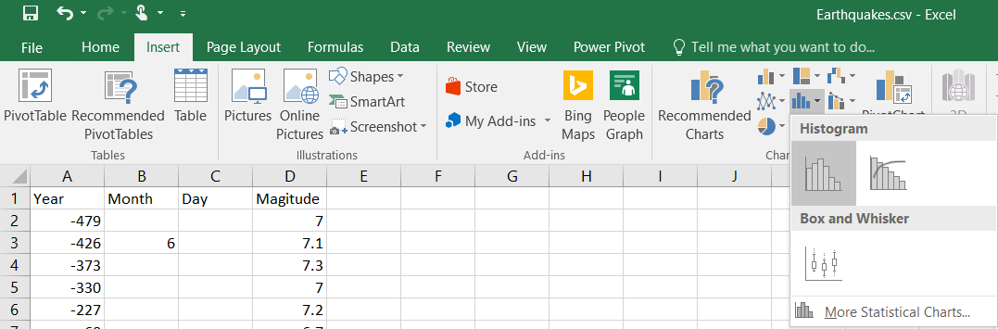

1. The result is the histogram.

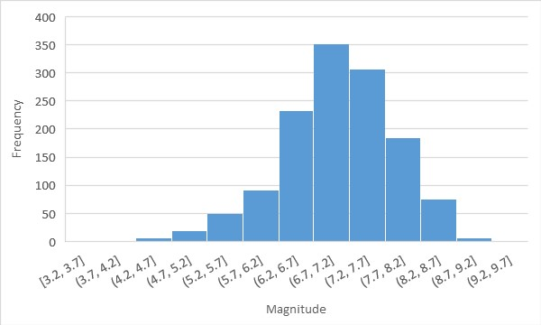

1. To change the bins width, double click on the **X axis**, the **Format Axis** will show on the right of the screen; select **Bin Width** and enter the appropriate width. (Let’s try 0.2)

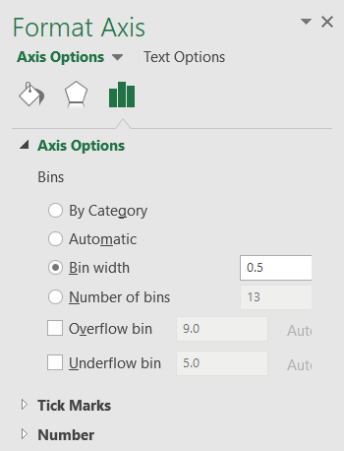

1. The result is

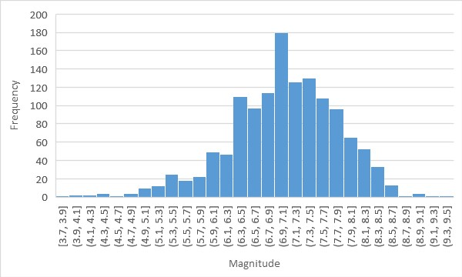

1. **Dot plot:**

**Pulse Rate Example:**

1. Open the data file (Pulse Rate.csv). In this file, there is one variables which is pulse rate. Select the range of the pulse rate variable.

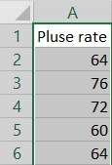

1. Select **Home** tab $⟹$**Sort & Filter $⟹$**  **Sort Smallest to Largest**. The observations will sort from smallest to largest.

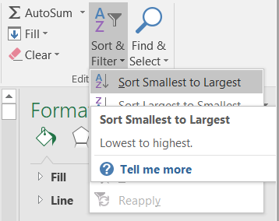

1. Create a new variable to count how many time the value are repeated. Select a cell and use the function **COUNTIF**; we can write as “=COUNTIF”.



or select it from **Formulas** tab $⟹$**More Functions $⟹$** **Statistical $⟹$** **COUNTIF**.

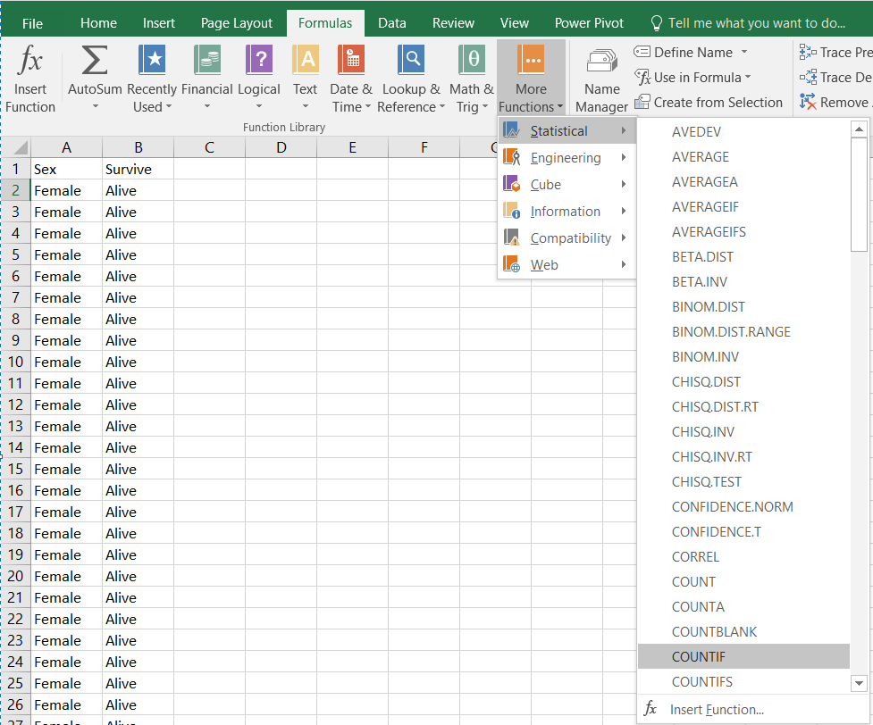

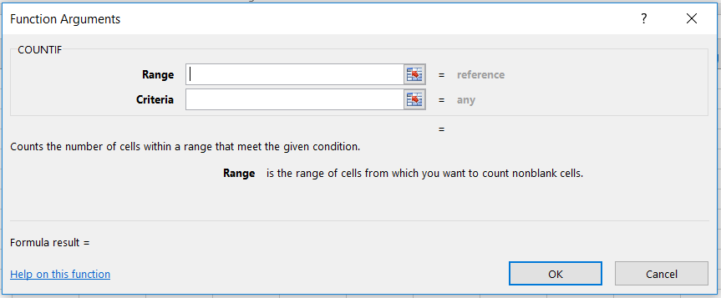

**range**: The range of cells to count (the range of the dataset).

**criteria**: The criteria that controls with cells should be counted.

Make sure to type the dollar sign ($) like the following formula



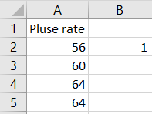

1. Copy and paste the formula in the next cells.

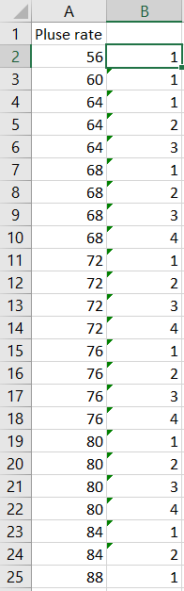

1. Select the two columns, then select **Insert** tab $⟹$**Recommended Charts**, **Insert Chart** will appear, then select **All Charts $⟹$** **X Y (Scatter)**, then click **OK**.

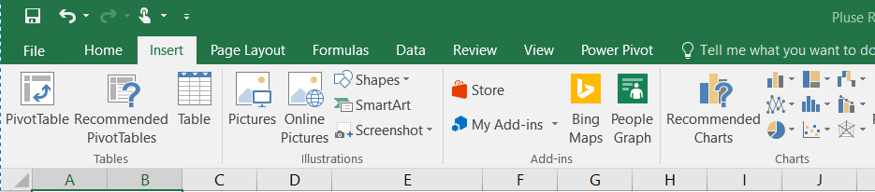

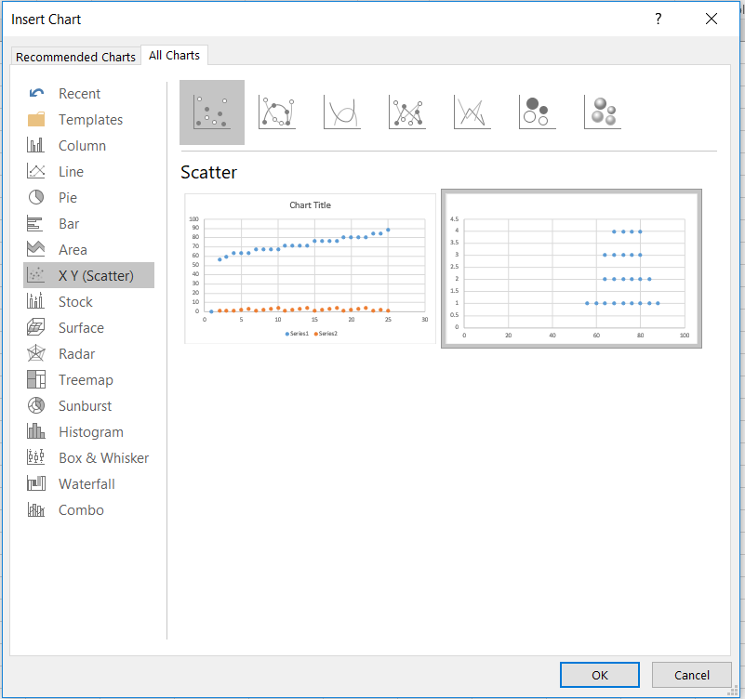

1. The results is a dot plot.

